**DATA ANALYTICS WITH EXCEL**

SUBJECT CODE: BCS358A

**LAB MANUAL**

1.Create a Worksheet of 20 Students (using auto fill) with Column Headers –Name, Subject 1 to Subject 6, Total, Percentage. Assign random marks to these subjects and make it constant. Perform the following operations

* 1. Perform a multilevel sort of your choice.
  2. Filter the Marks of students who got more than 65 marks in Subject 1 and Subject 5 using Number Filters options

Perform Conditional Formatting by highlighting a different colour to those cells where students have scored more than 65 marks in all the subjects

**Answer**

Click on Excel -> Blank Work Book

Type in the following Headers in the sequence

SLNo USN Name Sub1 Sub2 Sub3 Sub4 Sub5 Sub6 Total Percentage

Type in 1 in SLNo Column

Go to Home->Series->Series in->Columns-Type-> Linear -> Step Value ->1 – Stop Value ->20 ->OK

A series of 1 to 20 will be generated in the SLNo Column

Come to the USN Column -> Type in a USN -> Go to bottom right corner of an active cell -> double click or click and drag to fill USN for 20 members

Come to the Name Column -> Type the names for 20 people

To fill the marks for the 6 subjects, follow the below procedure

Go to the 1st student Sub1 marks cell, type in the formula =randbetween (35,99). A random number will be generated. Click and drag the formula to all the cells from Sub1 to Sub6 for all the 20 students to generate the random marks

To make it constant

Select all the cells where marks have been entered for 20 students -> Copy -> Paste -> PasteSpecial -> Values -> OK.

The values will remain constant

Calculate the Total column using “SUM” formula

Calculate the Percentage column using Total/Cell ref to the cell where 600 is stored.

1. Steps to Perform Multilevel sort

* Select the entire date
* Go to Data ribbon -> Sort and Filter section -> Click on SORT
* Sort by -> Sub2 - sort on ->Cell Values - Order-> Smallest to Largest
* Click on Add level
* Then by ->Sub5 – sort on -> Cell Values – Order -> Smallest to Largest.

1. Steps to use Number Filter Options

* Select the headers -> Home -> Sort and Filter -> Filter
* Click on Dropdown of Sub1 -> Number Filters -> Greater than -> 65 – The data will be filtered
* Then click on Dropdown of Sub5 -> Number Filters -> Greater than -> 65 – The data will be filtered

Conditional Formatting

Select the data from Sub1 to Sub6 marks for all 20 students -> Home -> Conditional Formatting -> Highlight cell rules -> Greater than -> Format cells greater than 65 with -> Custom Format -> Select your own custom choice.

**OUTPUT**

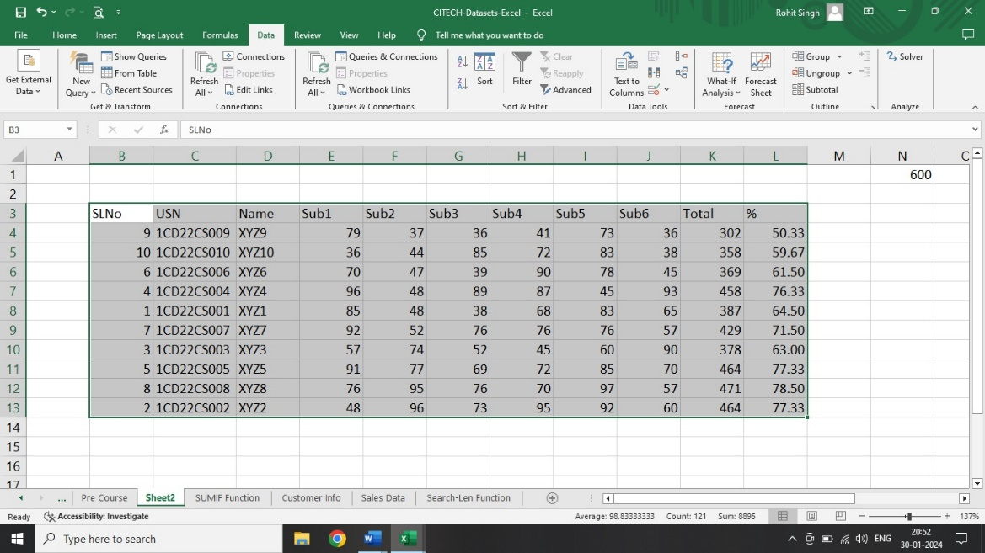

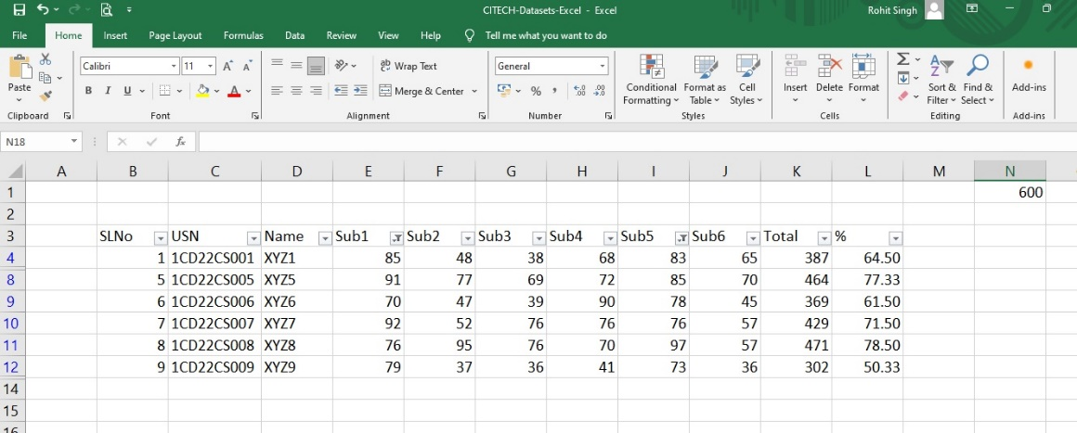

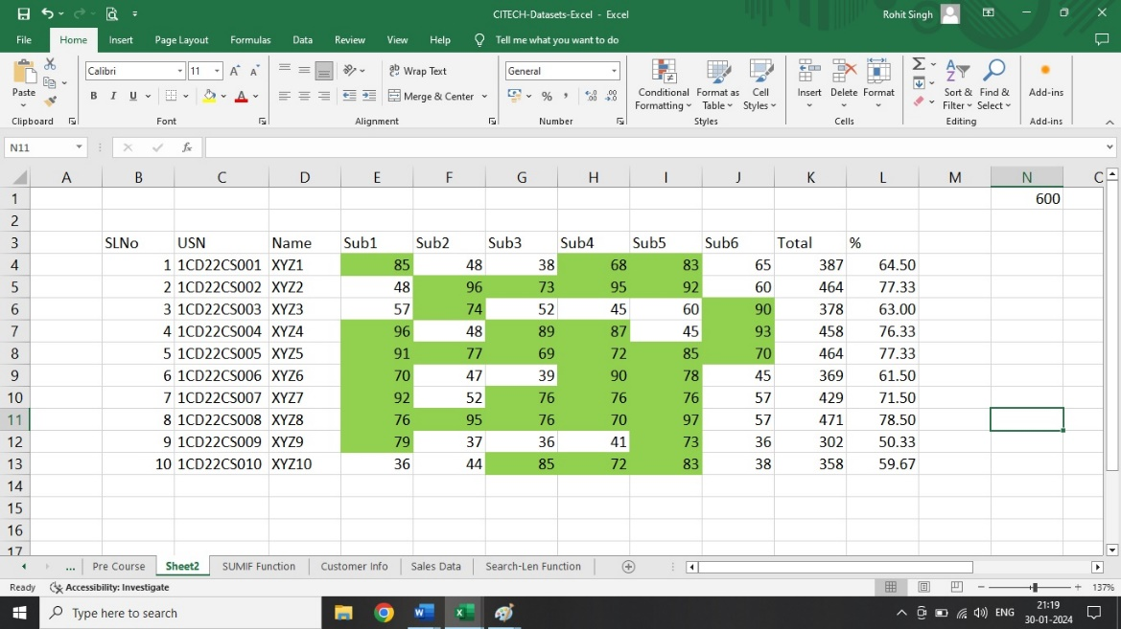

2.Create a Worksheet of 20 Students (using auto fill) with Column Headers –Name, Subject 1 to Subject 6, Total, Percentage. Assign random marks to these subjects and make it constant. Perform the following operations

a. Using Advanced Filter (AND, OR) –Filter the students who got more than 60 marks in Subject 2, more than 60 percent using **AND, OR** conditions

b. Perform Data Validation by creating a drop-down List for these 20 students and 7 subjects

**Answer**:

Click on Excel -> Blank Work Book

Type in the following Headers in the sequence

SLNo USN Name Sub1 Sub2 Sub3 Sub4 Sub5 Sub6 Total Percentage

Type in 1 in SLNo Column

Go to Home->Series->Series in->Columns-Type-> Linear -> Step Value ->1 – Stop Value ->20 ->OK

A series of 1 to 20 will be generated in the SLNo Column

Come to the USN Column -> Type in a USN -> Go to bottom right corner of an active cell -> double click or click and drag to fill USN for 20 members

Come to the Name Column -> Type the names for 20 people

To fill the marks for the 6 subjects, follow the below procedure

Go to the 1st student Sub1 marks cell, type in the formula =randbetween (35,99). A random number will be generated. Click and drag the formula to all the cells from Sub1 to Sub6 for all the 20 students to generate the random marks

To make it constant

Select all the cells where marks have been entered for 20 students -> Copy -> Paste -> PasteSpecial -> Values -> OK.

The values will remain constant

Calculate the Total column using “SUM” formula

Calculate the Percentage column using Total/Cell ref to the cell where 600 is stored.

1. Steps to Perform Advanced Filter

AND Condition

Type it the following way in any of the active cells

|  |  |
| --- | --- |
| Sub2 | % |
| >60 | >60 |

* Click on Data -> Sort & Filter -> Advanced
* Advanced Filter box will open
* Click on -> Copy to another location
* List Range -> Select the entire table
* Criteria range -> give the above table as the criteria
* Copy to -> Give a new cell address -> Click OK
* A new data based on the above filter will be created in the active cell specified in the “Copy To” section

1. Steps to perform Data Validation List

* Type in **USN** anywhere in the worksheet
* Go to the Cell below the USN which you have typed.
* Go to Data -> Data Tools -> Data Validation
* Data Validation dialog box will appear
* Click on -> Allow -> List, go to Source -> Select all the USN (except the heading) from the table -> Click on OK.
* A drop down will appear below the USN which was typed.
* ii. Steps to perform Data Validation List
* Type in **Subject** next to **USN** which was typed earlier in the worksheet
* Go to the Cell below the **Subject** which you have typed.
* Go to Data -> Data Tools -> Data Validation
* Data Validation dialog box will appear
* Click on -> Allow -> List, go to Source -> Select all the **Sub** (Sub1 to Sub7) from the table -> Click on OK.
* A drop down will appear below the **Subject** which was typed

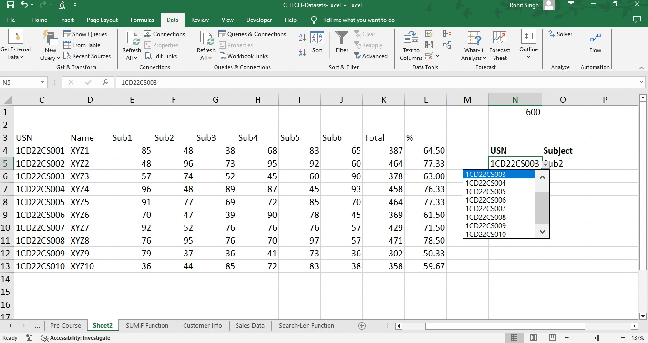

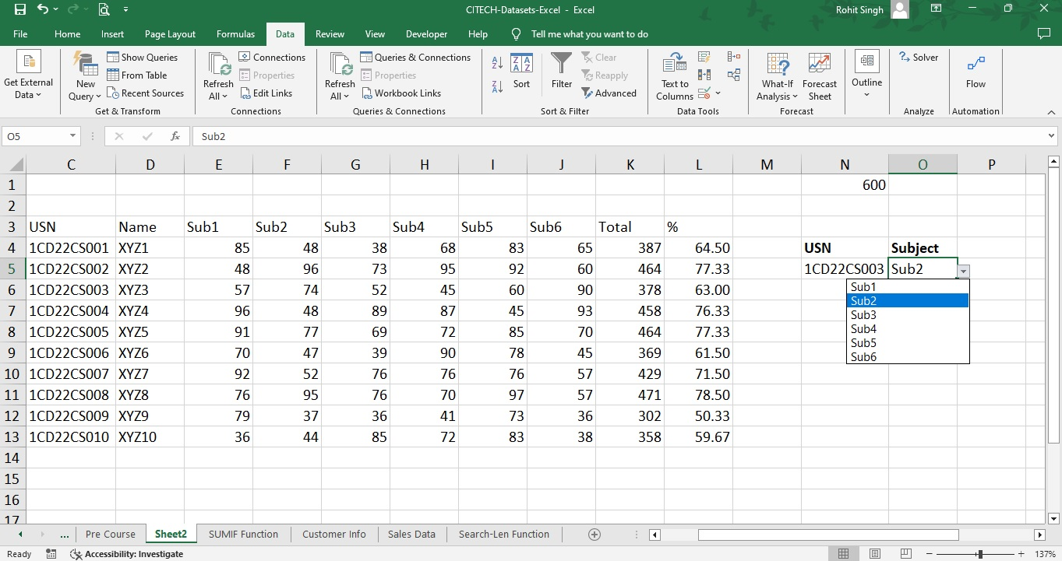

3. Create a Worksheet of 20 Students (using auto fill) with Column Headers –Name, Subject 1 to Subject 6, Total, Percentage. Assign random marks to these subjects and make it constant. Create a table for the above data and thereby create a chart. Perform the following operations

a. Copy the Chart to the Microsoft Word by creating a link between MS Excel and MS Word

b. Modify the data and look for the updated fields in the Charts in both MS Excel and MS Word

**Answer**:

Click on Excel -> Blank Work Book

Type in the following Headers in the sequence

SLNo USN Name Sub1 Sub2 Sub3 Sub4 Sub5 Sub6 Total Percentage

Type in 1 in SLNo Column

Go to Home->Series->Series in->Columns-Type-> Linear -> Step Value ->1 – Stop Value ->20 ->OK

A series of 1 to 20 will be generated in the SLNo Column

Come to the USN Column -> Type in a USN -> Go to bottom right corner of an active cell -> double click or click and drag to fill USN for 20 members

Come to the Name Column -> Type the names for 20 people

To fill the marks for the 6 subjects, follow the below procedure

Go to the 1st student Sub1 marks cell, type in the formula =randbetween (35,99). A random number will be generated. Click and drag the formula to all the cells from Sub1 to Sub6 for all the 20 students to generate the random marks

To make it constant

Select all the cells where marks have been entered for 20 students -> Copy -> Paste -> PasteSpecial -> Values -> OK.

The values will remain constant

Calculate the Total column using “SUM” formula

Calculate the Percentage column using Total/Cell ref to the cell where 600 is stored.

Select the data -> Press -> Ctrl + t -> to format as a Table

Select the data from Name till Sub 6 -> Insert -> Charts -> All Charts -> 3-D Column Stacked Chart.

1. Create the Link between MS Word and Excel for the Chart

* Select the Chart -> Copy.
* Now open the Word Document -> Click on Paste -> Keep Source Formatting and Link data -> The Chart will be Pasted.

1. Go to Excel -> Enter the new Student Record in the Table (All details). The chart will get updated in the Excel. Go to Word Document, the Chart will be updated in the Word as well, since we have created a link.

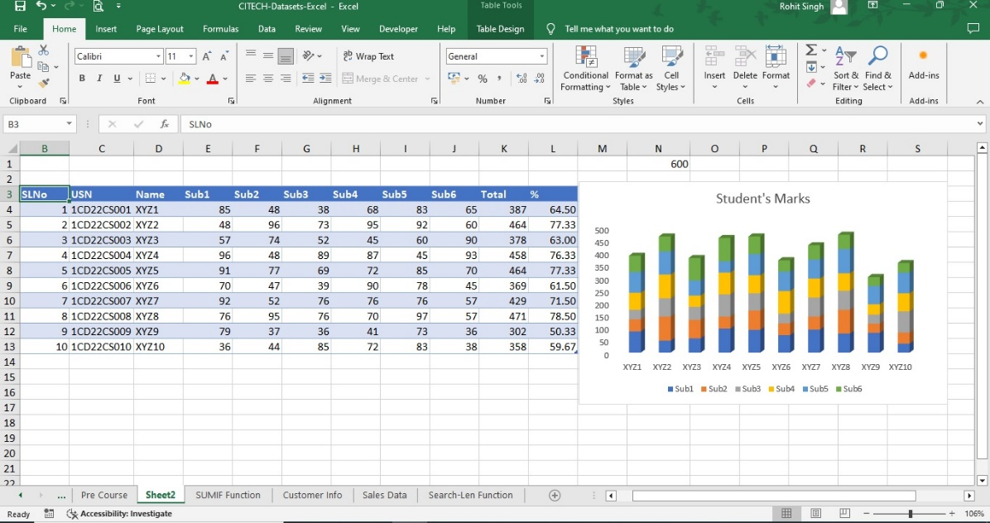

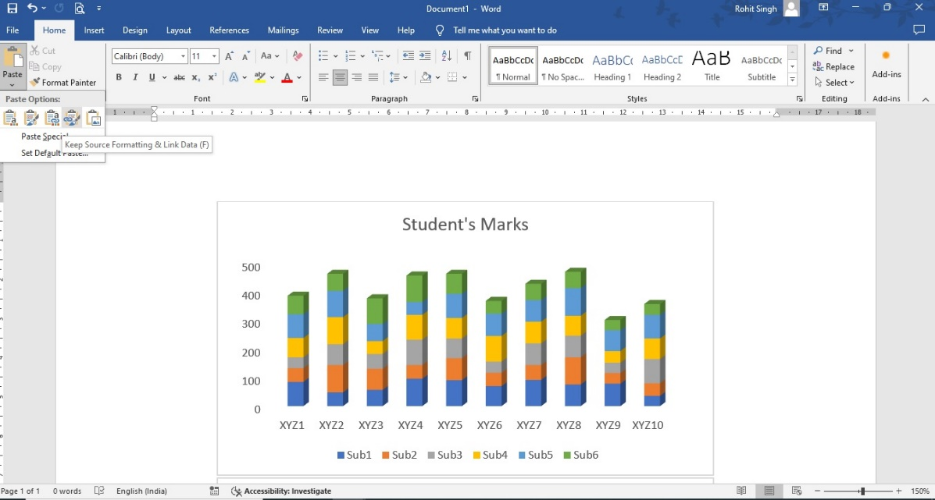

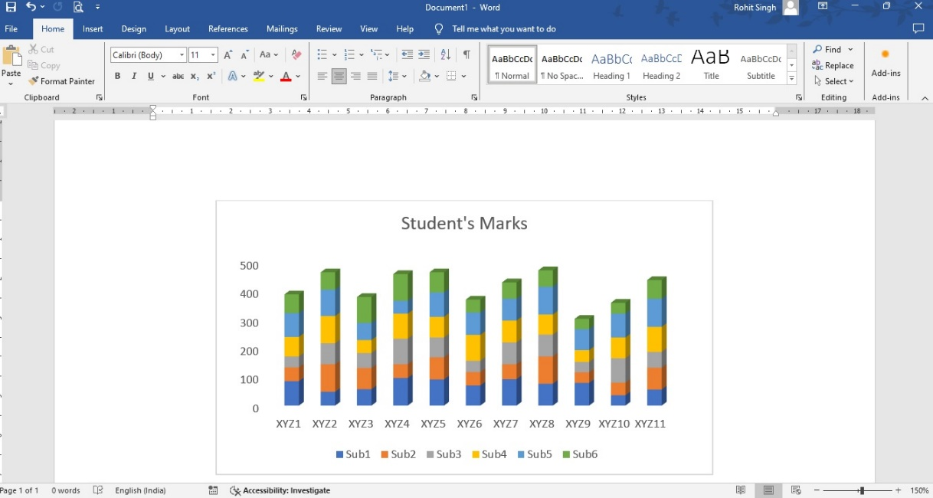

4. Create a Worksheet of 20 Students (using auto fill) with Column Headers –Name, Subject 1 to Subject 6, Total, Percentage. Assign random marks to these subjects and make it constant. Perform the following operations.

a. Calculate the Aggregate Functions for the Total Marks.

Average, Min, Max, Median, Mode, Standard Deviation.

b. Apply a particular font colour, font style, fill colour and apply it to all other headers using Format Painter

**Answer**

Click on Excel -> Blank Work Book

Type in the following Headers in the sequence

SLNo USN Name Sub1 Sub2 Sub3 Sub4 Sub5 Sub6 Total Percentage

Type in 1 in SLNo Column

Go to Home->Series->Series in->Columns-Type-> Linear -> Step Value ->1 – Stop Value ->20 ->OK

A series of 1 to 20 will be generated in the SLNo Column

Come to the USN Column -> Type in a USN -> Go to bottom right corner of an active cell -> double click or click and drag to fill USN for 20 members

Come to the Name Column -> Type the names for 20 people

To fill the marks for the 6 subjects, follow the below procedure

Go to the 1st student Sub1 marks cell, type in the formula =randbetween (35,99). A random number will be generated. Click and drag the formula to all the cells from Sub1 to Sub6 for all the 20 students to generate the random marks

To make it constant

Select all the cells where marks have been entered for 20 students -> Copy -> Paste -> PasteSpecial -> Values -> OK.

The values will remain constant

Calculate the Total column using “SUM” formula

Calculate the Percentage column using Total/Cell ref to the cell where 600 is stored.

1. Create new rows with Average, Mean, Median, Mode, Standard Deviation as the texts.

* Use appropriate formulas to get the above data with Total Marks Column as the input.
* Formulas to be used are:
* average (number1, number2, ……)
* mean (number1, number2, ……)
* mode (number1, number2, ……)
* stdev (number1, number2, ……)

1. Applying different background, font colour to all the headers using Format Painter.

* Select the SLNo column
* Make it bold -> ctrl +b
* Give a background colour -> Home -> Font Section -> paint symbol -> select blue
* Give a font colour -> Home -> A -> select White
* Increase font size to 14.
* Double Click on Format Painter -> Select all the headers to apply the Format -> hit Esc key to stop the format painter.

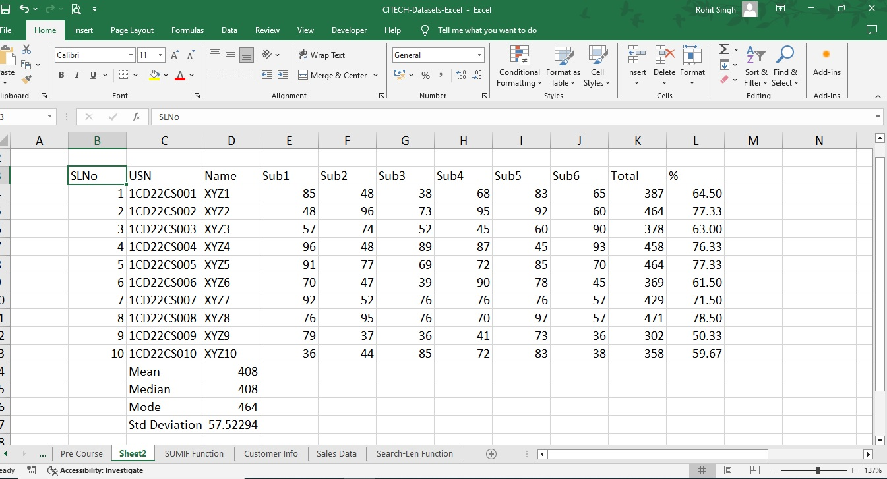

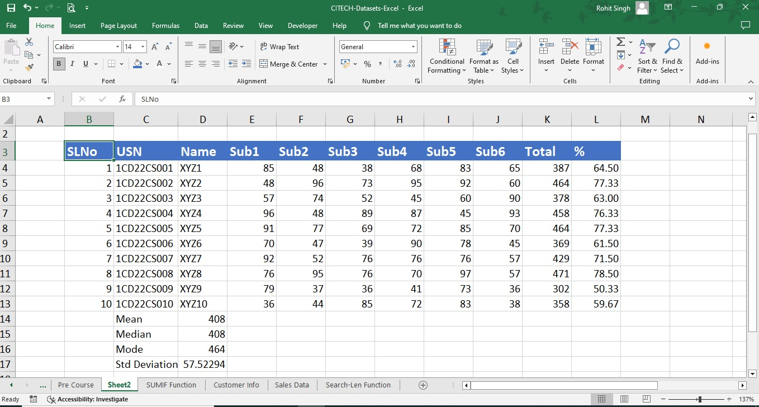

5. Write 10 Names (Give “FULL NAME” as the header) of your choice. Perform the following:

a. Separate the FULL NAME into FIRST NAME and LAST NAME into two different columns using

LEFT, RIGHT, SEARCH and LEN formulas.

b. Use UPPER, LOWER, TRIM, CONCATENATE formulas to showcase your results.

**Answer**

Open an Excel, write any 10 names of your choice, Give the header as FULL NAME.

1. To separate the Full Name into first name and last name we follow the procedure as explained below

* Use the LEFT formula to separate FULL NAME in First Name
* The arguments used for left function are as follows
* =**left (Text, numchars)**
* We will give the full name as text.
* To find the number of characters from left side we will make use of **search ()** formula which will search for the space in the FULL NAME. once it encounters the space, it will return the position where the space is found. We need to subtract -1 to get the first name

Example

* SACHIN TENDULKAR (stored in A2
* **left (A2, search (“ “ , A2, 1) -1))**
* The search will return 7 as the value which will be subtracted with -1 to get 6. Left formula will print 6 characters from the left end. Hence SACHIN will be separated.

Similarly, we make use of right formula to separate Last Name.

* The arguments in the **right ()** formula is same as the **left ()**
* =**right (Text, numchars)**
* Here in numchars we will make use of two formulas called **len ()** and **search ()**.
* len(text) will return the length of the characters in a text
* search () we will use to again search for the space in the FULL NAME text
* when we subtract the positions returned by the len and search formulas, we get the Last Name from the right end since the right () will return the number of characters from the right end.

Example:

* SACHIN TENDULKAR (stored in A2)
* **Right (A2, len(A2) – search (“ “, A2, 1))**
* Len will return the length of the text which is 16 and search will return the position of space which is 7, when they are subtracted numchars will store the value 16-7=9. The **right ()** will return 9 characters from the right end which is TENDULKAR.

1. The upper (“text”) will convert the entire text into UPPER CASE

The lower (“text”) will convert the entire text into LOWER CASE

The trim (“text”) will remove any extra spaces and will keep only one space in the text

The concatenate (text1, text2, …….) will join two or more texts to give a new text.

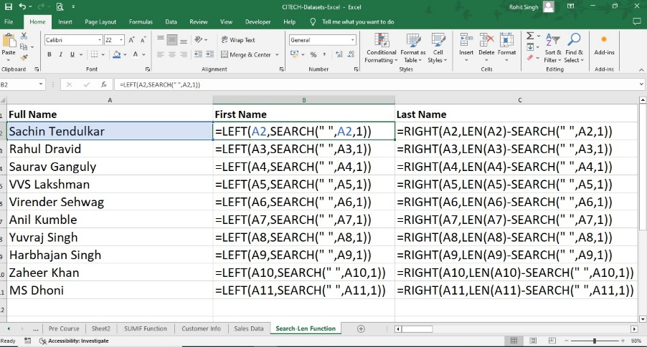

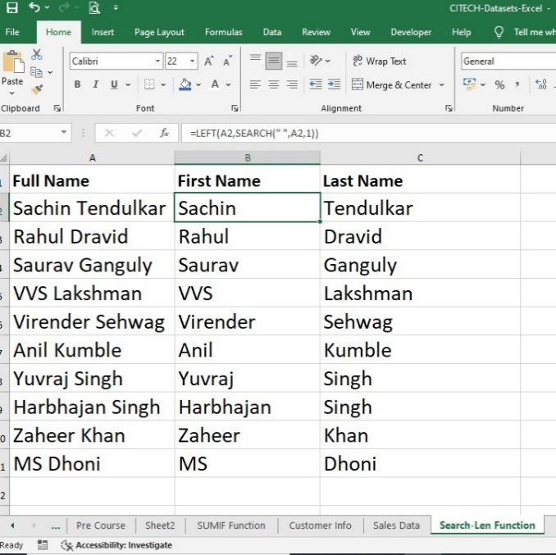

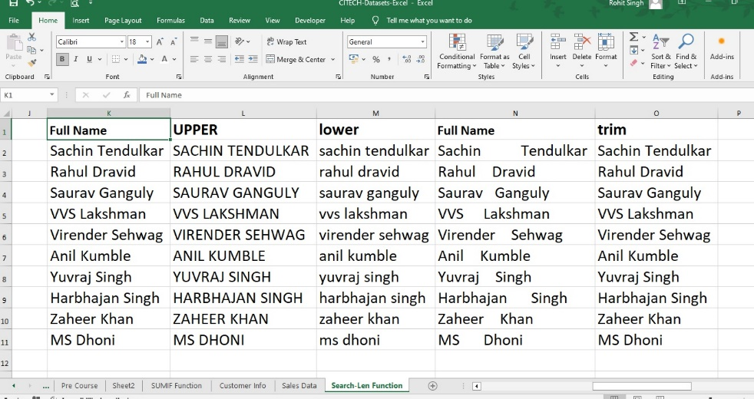

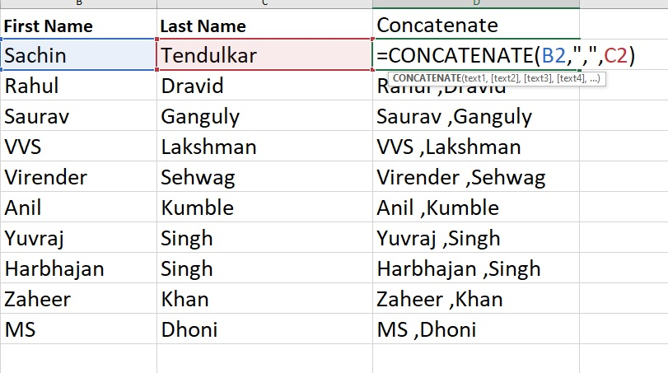

6. Input a Date and Time and perform the following operations

DATEVALUE, DATEDIF, TIMEVALUE

Use CONCATENATE formula to Concatenate the number of years, months, and days after using DATEDIF formula

Ex: 24 Years 3 Months 16 Days

**Answer:**

DATEVALUE

* The function converts a date that is stored as text to a serial number that Excel recognizes as a date.
* The DATEVALUE function is helpful in cases where a worksheet contains dates in a text format that you want to filter, sort, or format as dates, or use in date calculations

Syntax: DATEVALUE (date_text)

The DATEVALUE function syntax has the following arguments:

* Date_text Required. Text that represents a date in an Excel date format, or a reference to a cell that contains text that represents a date in an Excel date format. For example, "1/30/2008" or "30-Jan-2008" are text strings within quotation marks that represent dates.
* Using the default date system in Microsoft Excel for Windows, the date_text argument must represent a date between January 1, 1900 and December 31, 9999. The DATEVALUE function returns the #VALUE! error value if the value of the date_text argument falls outside of this range.

TIMEVALUE

* Returns the decimal number of the time represented by a text string. The decimal number is a value ranging from 0 (zero) to 0.99988426, representing the times from 0:00:00 (12:00:00 AM) to 23:59:59 (11:59:59 P.M.).

Syntax: TIMEVALUE (time_text)

* The TIMEVALUE function syntax has the following arguments: Time_text Required. A text string that represents a time in any one of the Microsoft Excel time formats; for example, "6:45 PM" and "18:45" text strings within quotation marks that represent time.

DATEDIF

Calculates the number of days, months, or years between two dates.

Syntax: DATEDIF (start_date, end_date, source)

* start_date A date that represents the first, or starting date of a given period. Dates may be entered as text strings within quotation marks (for example, "2001/1/30"), as serial numbers (for example, 36921, which represents January 30, 2001, if you're using the 1900 date system), or as the results of other formulas or functions (for example, DATEVALUE ("2001/1/30")).
* end_date A date that represents the last, or ending, date of the period.

source :

* The type of information that you want returned, where
* "Y" - The number of complete years in the period.
* "M" - The number of complete months in the period.
* "D" - The number of days in the period.
* "MD" - The difference between the days in start_date and end_date. The months and years of the dates are ignored.
* "YM" - The difference between the months in start_date and end_date. The days and years of the dates are ignored
* "YD" - The difference between the days of start_date and end_date. The years of the dates are ignored.

Use “concatenate” function to concatenate the Years Months and Days.

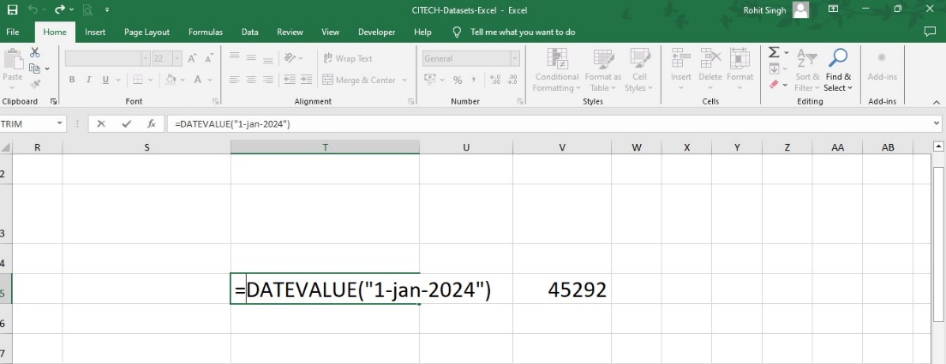

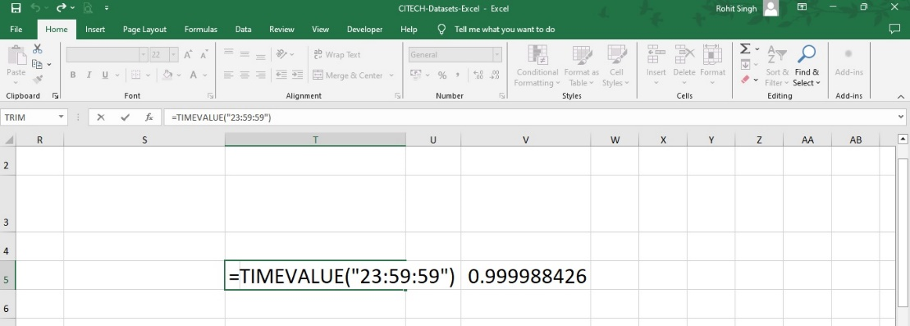

++++++++++++++

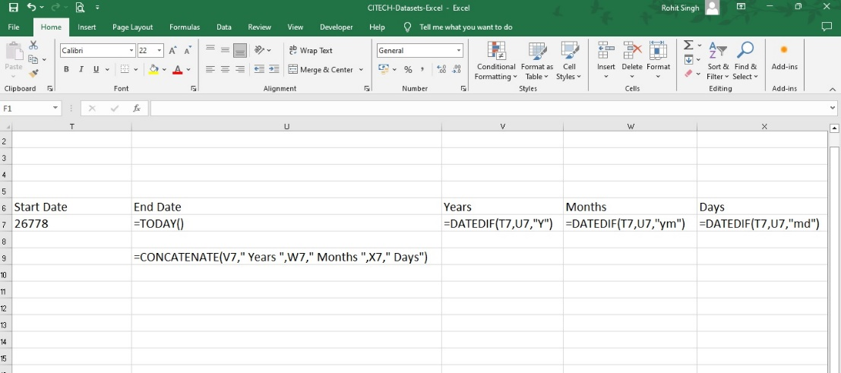

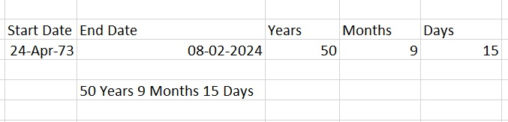

7. Calculate the EMI by giving i. Loan Amount, ii. Rate of Interest ii. No of Years as the input,

Use What-if Analysis – Goal Seek to find new EMI by changing any of the i, ii, or iii

Create Data Table for the EMI by changing the No of Years and Rate of Interest as the inputs.

**Answer**

Create data with the above 3 headings in 3 rows. Find the EMI, using the pmt () function. And then perform the following operations as specified.

What-if Analysis

Goal Seek

* Go to Data -> What-if Analysis -> Goal Seek
* Set cell - to the EMI value we got using the pmt () function
* To Value - new EMI of your choice
* By changing cell - give the cell reference where the interest rate is keyed in.
* Click OK. A new interest rate would be shown based on the EMI value which was set in.

Data Tables

* Create a table with Interest rates as the Columns and No of Years as Rows.
* Give in various values of your choice.
* At the junction where these two tables meet, copy and paste the EMI which was evaluated using pmt () function.
* Select the entire table consisting of the rows and columns which was entered
* Go to Data -> What if Analysis -> Data Tables -> row in put cell – Input **No of years** cell reference data value which was created to find EMI -> Column Input cells -> Input the **interest rate** cell reference data value which was created to find the EMI.
* A data table will be created which shows varied EMI’s.

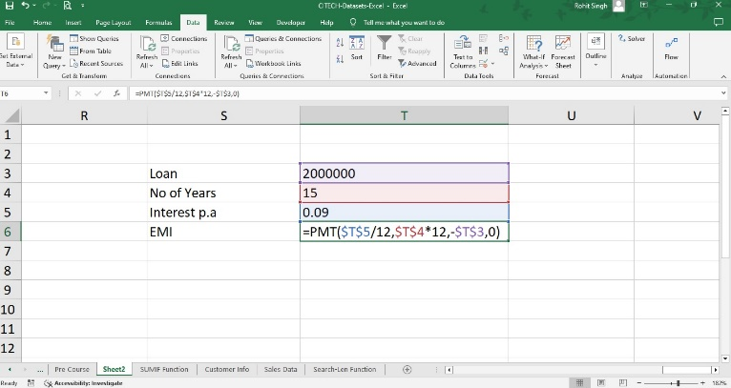

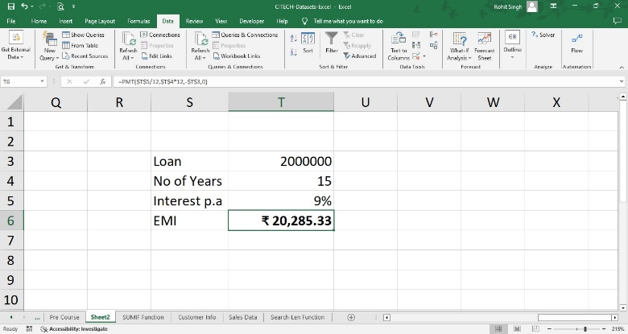

20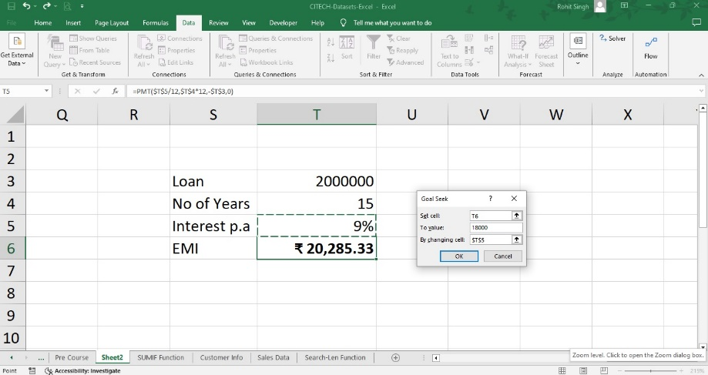

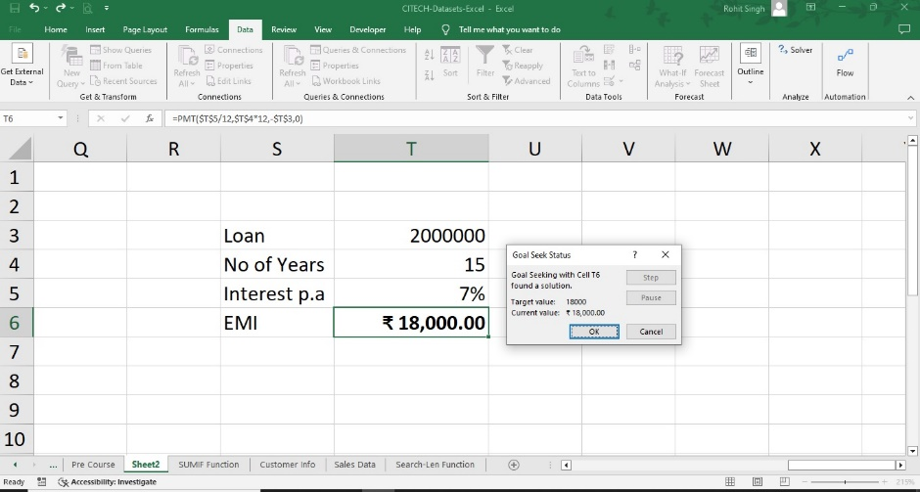

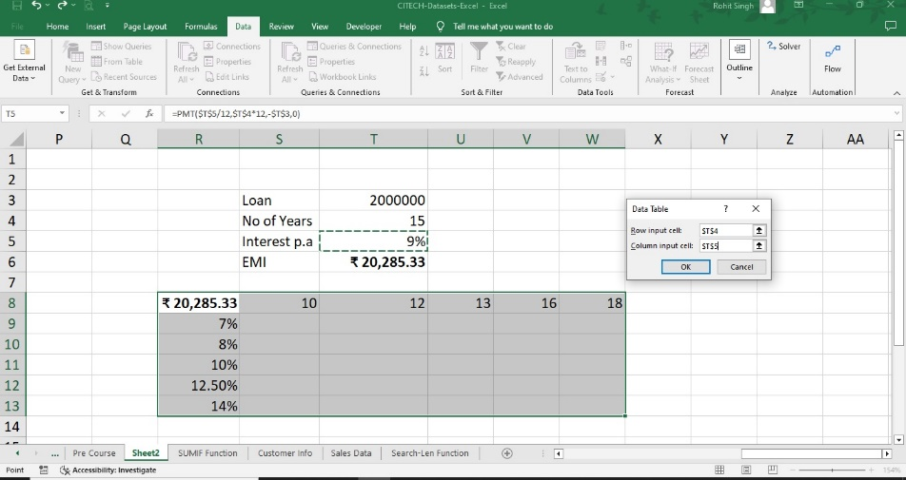

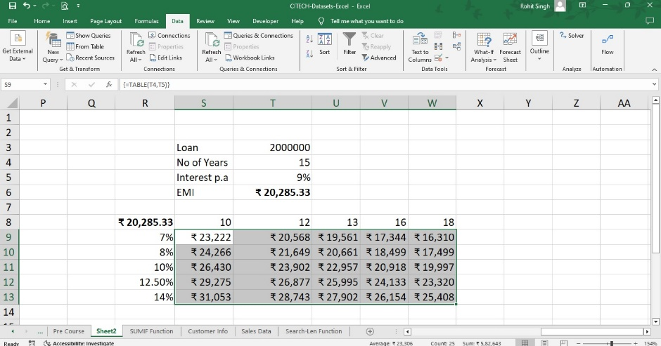

8. Analyse the data using Pivot Tables and Pivot Charts. Put Sales (in values field), Salesperson (in rows field), Year (in rows field) and the Type (in columns field). Perform the following operations

a. Create a new column next to Sum of Sales as Average of Sales and find the Average of sales based on the Year

b. Change the Currency format from the Pivot Table Fields section

c. Insert Slicers to Modify the Data

d. Create a Pivot Chart

**Answer**

We have a dataset with us called Sales Data which we would be using to create a pivot table.

Select the data -> Convert into a table -> Ctrl + t

Select the data -> Insert -> Pivot Table -> New Worksheet -> Ok

A new worksheet will be created with the Pivot Table fields.

* Select the Year -> Click and drag to the Rows
* Select the Sales -> Click and drag to Σ Values -> Sum of sales will be displayed for all the three years
* Select the Sales -> Click and drag to Σ Values -> Sum of Sales2 will appear -> Right click onto it -> Value field Settings -> Summarize Values b y -> select Average -> Custom Name -> Change to Average of Sales -> OK. The Average of Sales would be displayed.
* Select the Year -> Click and drag to the Rows
* Select the Type -> Click and drag to the Columns
* Select the Salesperson -> Click and drag to the Rows
* Select the Sales -> Click and drag to Σ Values
* Pivot table will display all Sum of Sales as specified in the above fields.
* Go to Σ Values -> Right Click on Sum of Sales -> Value Field Settings -> Number Format -> Currency -> select the rupee symbol ₹ and decimal make it 0 -> Ok -> Ok
* The Currency format will be displayed.
* Select the Year -> Click and drag to the Rows
* Select the Type -> Click and drag to the Columns
* Select the Salesperson -> Click and drag to the Rows
* Select the Sales -> Click and drag to Σ Values
* Pivot table will display all Sum of Sales as specified in the above fields.
* Go to PivotTable Analyze -> Click on Insert Slicer -> Select: Year, Salesperson, Type -> Click on OK
* The Slicers will be available. Arrange the slicers accordingly to make the data look presentable.
* Click on any Slicer to modify the data. To multiselect - > Click on the multiselect button available next to the Slicer header to multiselect the items in each slicer.
* Select the Year -> Click and drag to the Rows
* Select the Type -> Click and drag to the Columns
* Select the Salesperson -> Click and drag to the Rows
* Select the Sales -> Click and drag to Σ Values
* Pivot table will display all Sum of Sales as specified in the above fields.
* Keep the active cell inside the data -> go to PivotTable Analyze -> Pivot Charts -> Select the Chart of your choice -> OK
* A chart will appear and you can modify the chart by
* First select the chart -> Design -> Add chart elements or click on Change Chart Type to change the chart selection.

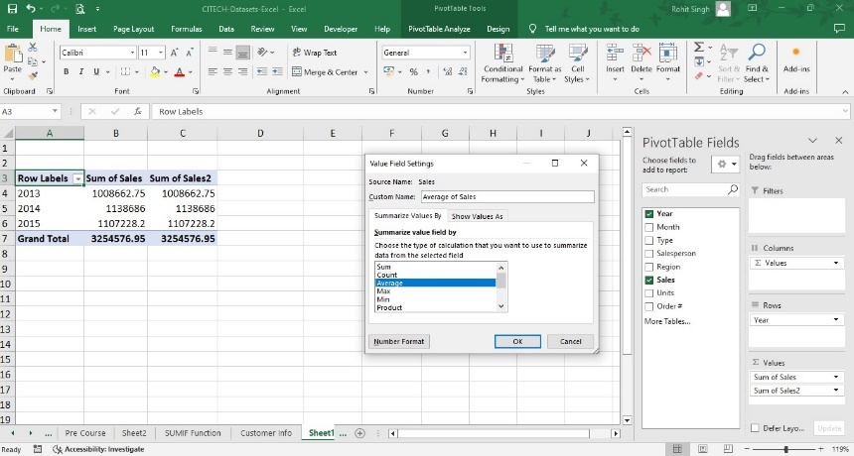

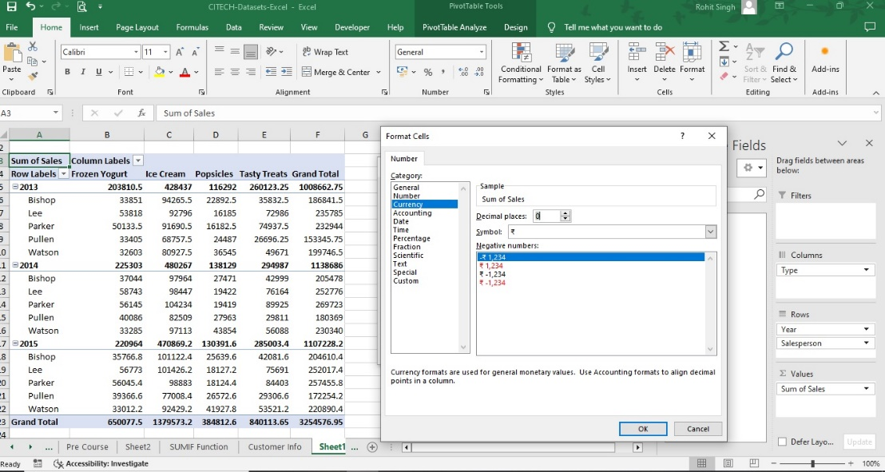

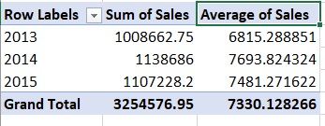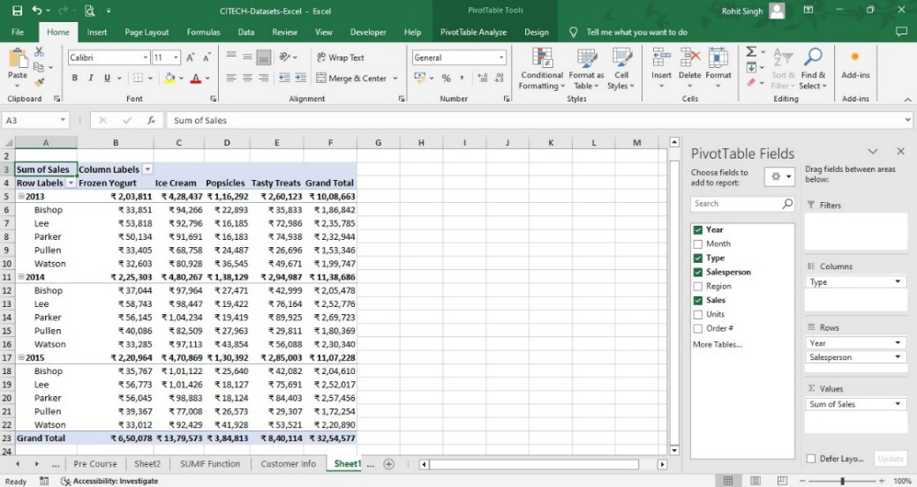

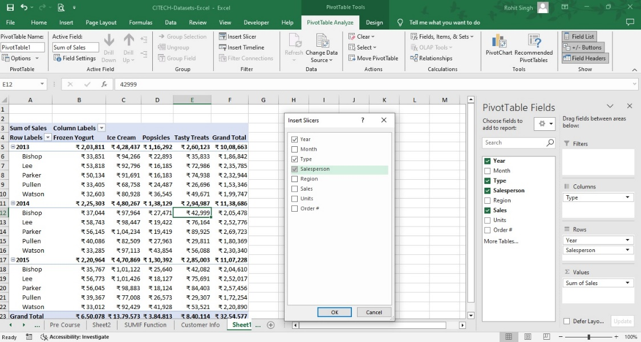

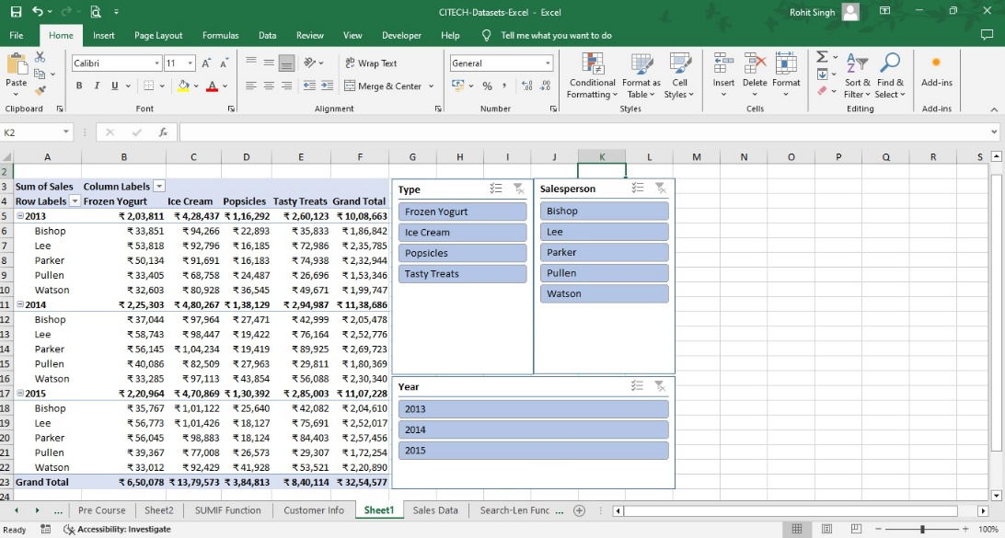

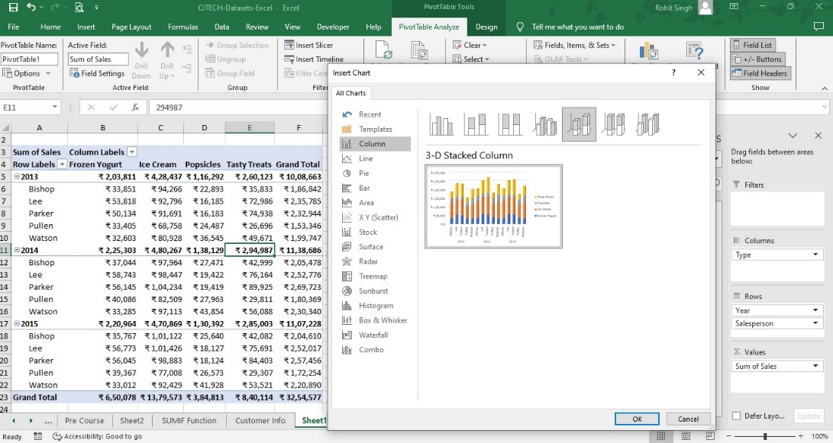

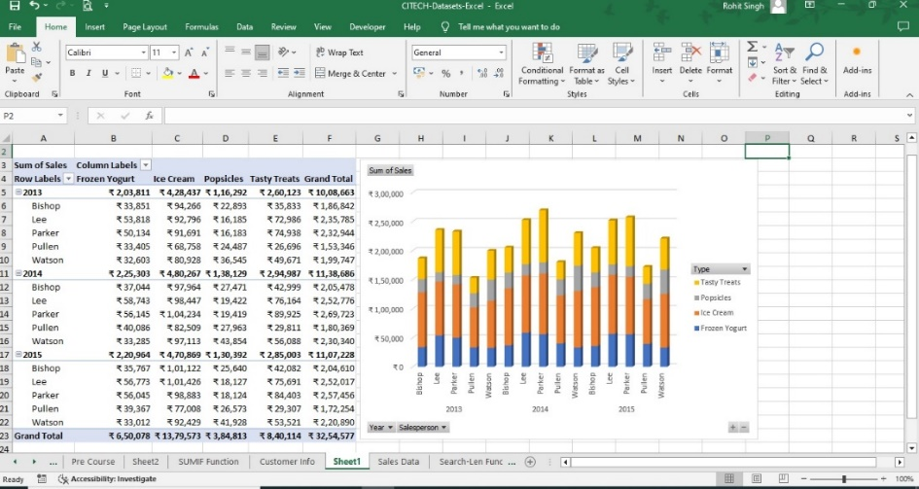

9. Create worksheet with following fields: Empno, Ename, Basic Pay(BP), Travelling Allowance(TA), Dearness Allowance(DA), House Rent Allowance(HRA), Income Tax(IT), Provident Fund(PF), Net Pay(NP). Use appropriate formulas to calculate the above scenario. Analyse the data using appropriate chart and report the data.

**Answer:**

* Create columns with the headers as given in the question.
* Create records of 10 people and use the following formulas to find the solutions and arrive at Net Pay
* Dearness Allowance (DA) = 20% of Basic Salary
* House Rent Allowance (HRA) = 12% of Basic Salary
* Travel Allowance( TA) – ₹2000/-
* Gross Pay = Basic Pay + DA + HRA + TA.
* The deductions will be as follows
* Income Tax (IT) = 30% of Gross Pay
* Provident Fund (PF) – 12.5% of Gross Pay
* Net Pay = Gross Pay – sum (IT + PF).
* Generate Net Pay for all the 10 records using this formula.
* Convert the data into a Table by using “Ctrl + t”.
* Select data of your choice to create a Chart of your choice.
* Here we are selecting the EName, Gross Pay and Net Pay as the input for the Chart.

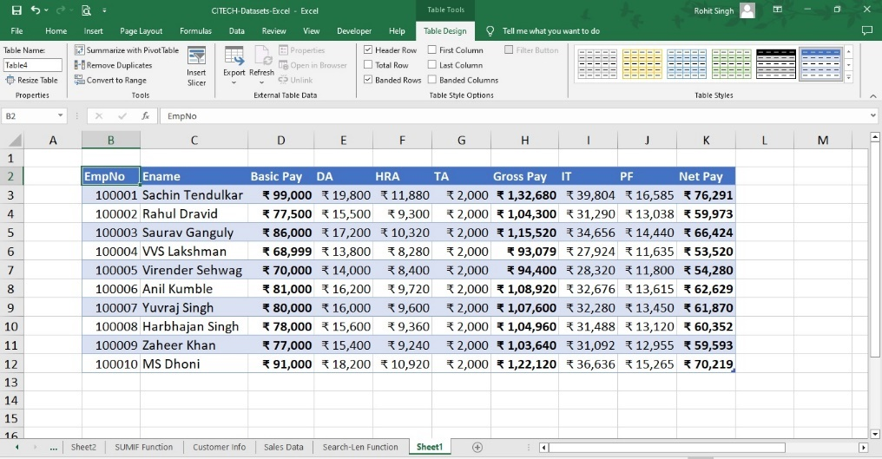

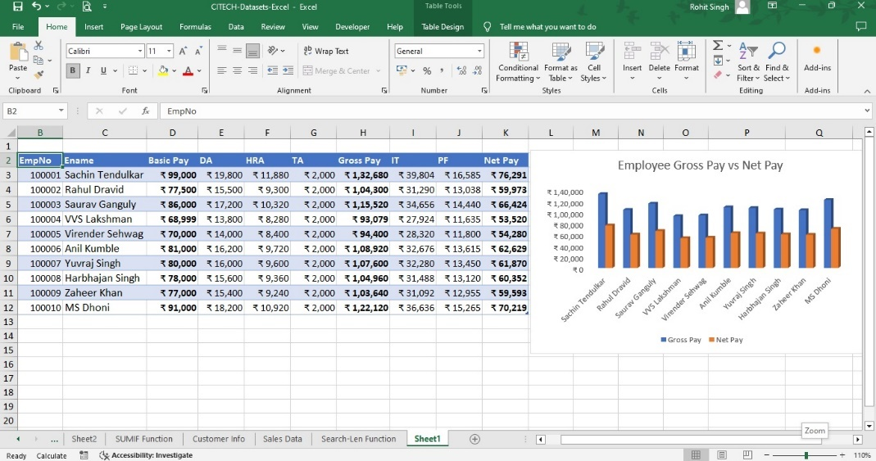

10. Create worksheet on Inventory Management: Sheet should contain Product code, Product name, Product type, MRP, Cost after % of discount, Date of purchase. Use appropriate formulas to calculate the above scenario. Analyse the data using appropriate chart and report the data.

**Answer:**

* Create columns with the headers as given in the question.
* Create records of 25 items and use the following formulas to find the solutions and arrive at Net Price
* Give the Quantity, MRP and Discount % of your choice.
* Calculate the Net Price after Discount using the formula below
* Net Price = MRP * (1- Discount%).
* We will get a list of all items at their Net Price.
* Select the data and convert it into a Table using “Ctrl + t”
* Select the Data and Use the chart of your choice.

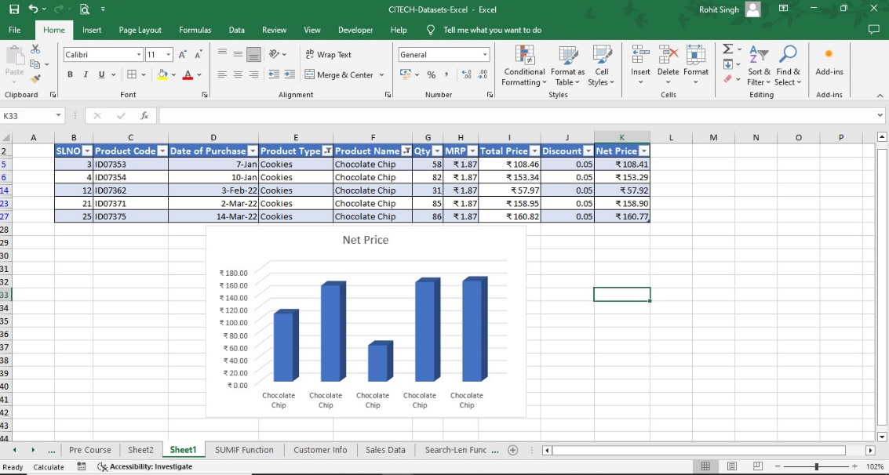

11. 11. Create worksheet on Sales analysis of Merchandise Store: data consisting of Order ID, Customer ID, Gender, age, date of order, month, online platform, Category of product, size, quantity, amount, shipping city and other details. Use of formula to segregate different categories and perform a comparative study using pivot tables and different sort of charts

**Answer:**

* Create the Table as shown above in the Excel Worksheet.
* Calculate the Total Price as Price/Qty * Qty.
* Also find the Days to delivery by subtracting Shipped Date with the Order Date
* Convert it into a table using “Ctrl + t”
* Go to -> Insert -> Pivot Table -> New Worksheet -> Ok.
* Go to Pivot Table fields and perform operations of your choice.

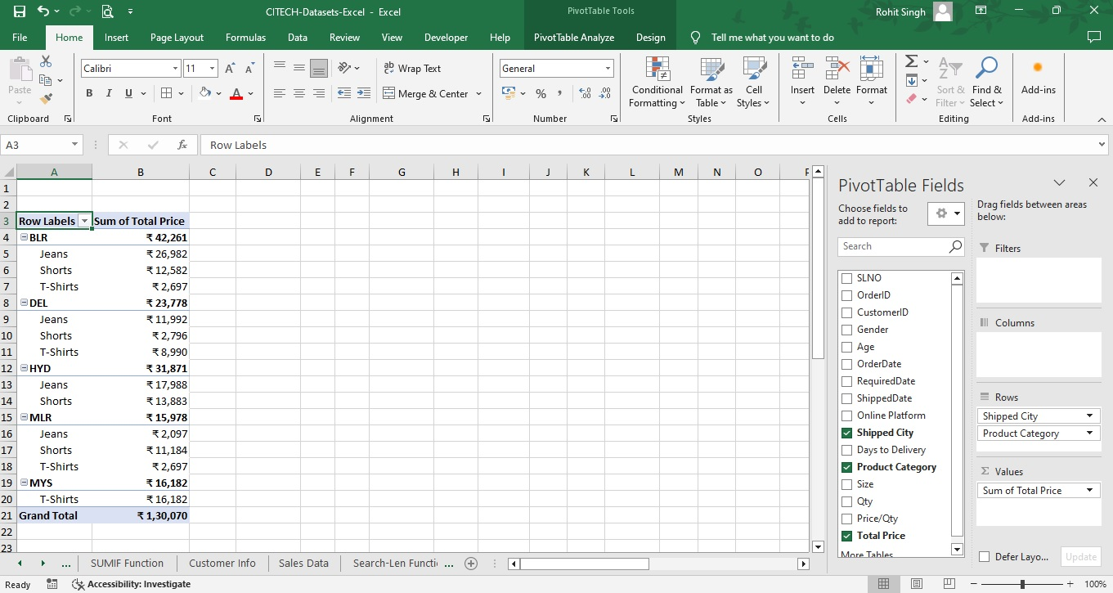

12.Create a Worksheet of 20 Students (using auto fill) with Column Headers –Name, Subject 1 to Subject 6, Total, Percentage. Assign random marks to these subjects and make it constant. Create and Record a MACRO to Format the Headers. Run the MACRO to showcase your results

**Answer:**

* Open an Excel Workbook
* Type in the USN, Name, Sub1 to Sub 6, Total Percentage in the Columns.
* Give the USN in the first column, Click and Drag the USN till 20 rows. Go to the next Column -> Name. Give Name as XYZ1, click and drag till 20 rows.
* Go to the third column ie Sub1. In the active cell type in the following formula
  + =randbetween (35,99) -> =randbetween (bottom,top)
* A random number will be allocated in that cell.
* Click and drag till Sub 6 for the first student and thereby for the 20th student and fill the excel sheet with marks for all the 20 students.
* However the numbers will be volatile and will keep changing again and again. Hence we got to make it constant.
* To make the numbers constant. Select all the numbers for all 20 students from subject 1 to subject 6. Copy -> Go to PASTE -> PASTE SPEIAL -> Click on Values -> OK.
* The values have become constant now.
* Use SUM and PERCENTAGE function to find the Total Marks and Percentage of these 20 students
* Open a Word Document. Go to VIEW RIBBON -> Macros Group -> Click on Record Macro
* A new Dialog Box will open. Give a Macro Name of your choice. A keyboard shortcut of your choice, If you want to describe what your MACRO does, give the details in Description Section. Click on OK.
* The MACRO has started Recording.
* Go to Insert Ribbon -> Click on Table -> Select 20 rows and 11 Columns.
* Fill in the details as specified in the question in the 11 columns. Format the HEADERS by giving a different font size, colour and background colour.
* Once all this is done. Go to VIEW -> Macros -> Stop Recording.
* The Macro has been recorded.
* Open a new Excel Workbook with the data. Click on VIEW RIBBON -> Macros Group -> View Macros -> Select the Macro Name which you have given. Click on RUN.
* The Macro will run and will insert the Table with all the details within a fraction of a second.

